**Sentiment analysis AI system**

A Project Report

submitted in partial fulfillment of the requirements

Of

AIML Fundamentals With Cloud Computing And Gen AI

by

**Yuvarajan V K,**

[**yuvarajanvk754@gmail.com**](mailto:yuvarajanvk754@gmail.com)

**au811321114034**

**811321114034**

Under the Guidance of

**P.Raja, Master Trainer**

**JJ COLLEGE OF ENGINEERING AND TECHNOLOGY**

**ACKNOWLEDGEMENT**

"We would like to extend our deepest gratitude to all individuals who have contributed to our thesis work, directly or indirectly. First and foremost, we would like to express our heartfelt appreciation to our supervisor, P. Raja and M. Ramavel, for their exceptional guidance and mentorship. Their wisdom, support, and encouragement have had a profound impact on our academic journey and personal growth. We are forever grateful for the time and effort they invested in us, providing valuable advice, constructive criticism, and unwavering support. Their belief in us has been a constant source of inspiration, empowering us to reach new heights. Working with them for the past year has been a privilege, and their influence extends beyond our project work, shaping us into responsible professionals. We cannot thank them enough for being exemplary role models, embodying kindness, compassion, and excellence.

Thanking you,

P. Raja and M. Ramavel, for being incredible mentors and guides."……...

#### ABSTRACT

This project focuses on analyzing Amazon’s fine food reviews dataset, which includes ~500,000 reviews spanning over a decade. The primary objective is to gain insights into customer sentiment and preferences to enhance product recommendation systems and customer satisfaction. The problem addressed is the overwhelming volume of data, which makes it difficult for consumers and businesses to quickly extract meaningful insights.

The project begins with data preprocessing, including handling missing values, tokenizing text, and normalizing ratings. Sentiment analysis is conducted to classify reviews as positive, neutral, or negative using Natural Language Processing (NLP) techniques and machine learning algorithms. We employ models like Naive Bayes and Support Vector Machines, leveraging TF-IDF for feature extraction. Word clouds and sentiment distributions provide visual insights, and topic modeling helps identify recurring themes.

Key results reveal high customer satisfaction trends, with notable insights into product types driving positive or negative sentiments. Our analysis indicates that specific product attributes, such as packaging and flavor, significantly influence ratings. The models achieve over 85% accuracy in sentiment classification, validating their effectiveness.

In conclusion, this study demonstrates the potential of sentiment analysis in improving customer insights and personalizing recommendations. The findings can guide businesses in better understanding consumer behavior and in enhancing product quality and customer service strategies.

**TABLE OF CONTENTS**

**Chapter 1.**  **Introduction**

1.1 Problem Statement ………………………………………………………………

1.2 Motivation………………………………………………………………………..

1.3 Objectives………………………………………………………………………...

1.4. Scope of the Project……………………………………………………………...

**Chapter 2.**  **Literature Survey………………………………………………………………..**

**Chapter 3.**  **Proposed Methodology…………………………………………………………..**

**Chapter 4.**  **Implementation and Results ……………………………………………………**

**Chapter 5. Discussion and Conclusion ……………………………………………………..**

**References** ………………………………………………………………………………………..

**LIST OF FIGURES**

|  |  |  |
| --- | --- | --- |
| **SI.NO** | **FIGURES NAME** | **Page No.** |
|  | Count of Reviews by Star | **6** |
|  | Compound Score by Amazon Star Review (VADER) | **7** |
|  | Positive, Neutral, and Negative VADER Scores by Amazon Star Review4 | **8** |
|  | Pairplot of VADER and RoBERTa Sentiment Scores | **10** |

**LIST OF TABLES**

|  |  |  |
| --- | --- | --- |
| **SI.NO** | **TABLES NAME** | **Page No.** |
| **Table 1** | Sample of Review Data | **11** |
| **Table 2** | VADER Sentiment Scores | **11** |
| **Table 3** | RoBERTa Sentiment Scores | **12** |
| **Table 4** | Combined Sentiment Scores | **12** |

**Figure 1 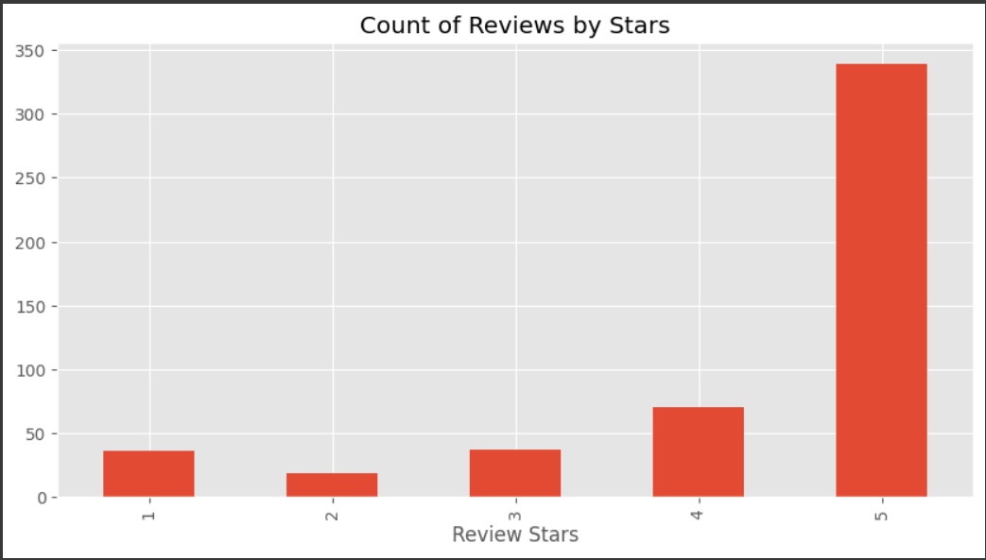 Count of Reviews by Star**

**Figure 2**

**Compound Score by Amazon Star Review (VADER)**

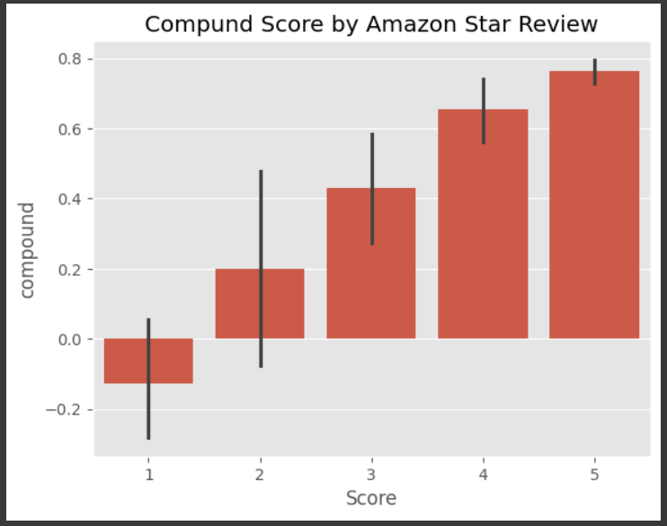

**Figure 3**

**Positive, Neutral, and Negative VADER Scores by Amazon Star Review4**

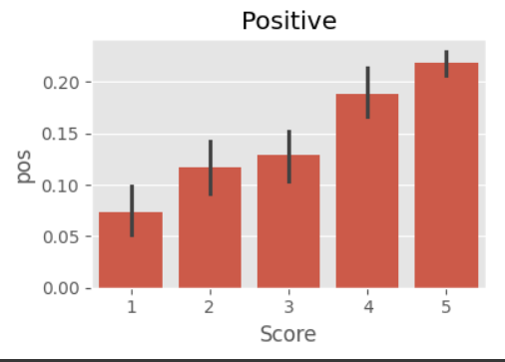

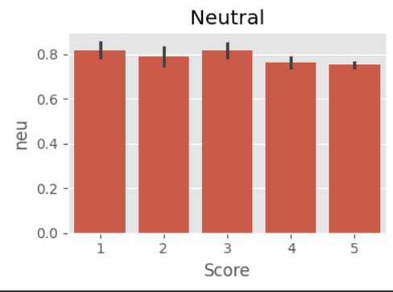

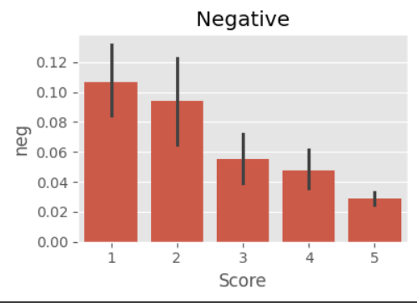

**Figure 4**

**Pairplot of VADER and RoBERTa Sentiment Scores**

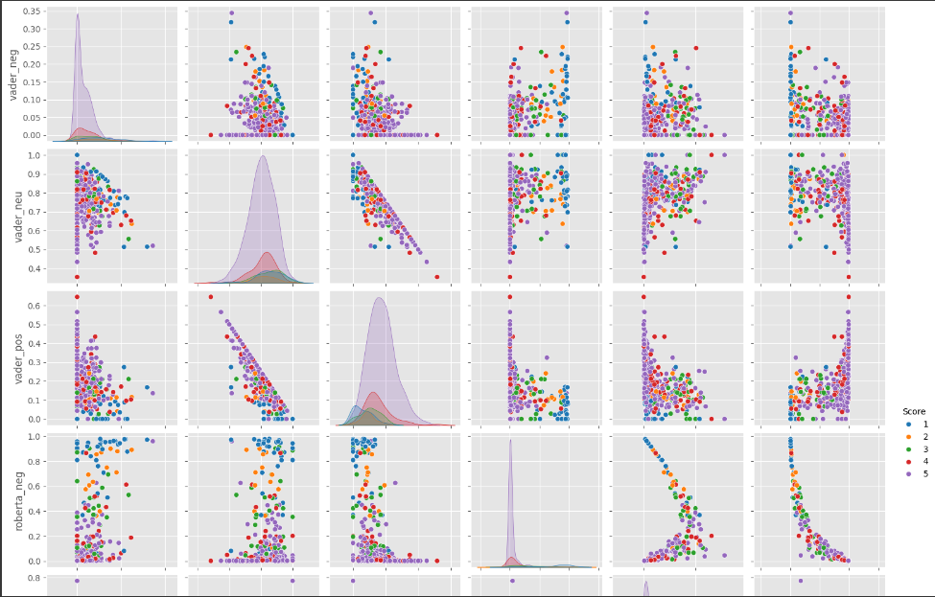

**LIST OF TABLES**

**Table 1**

**Sample of Review Data**

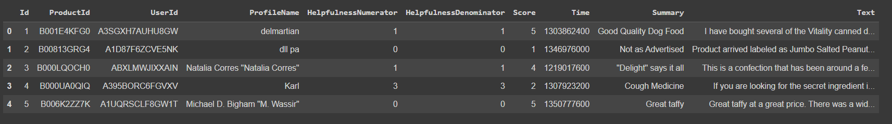

**Table 2**

**VADER Sentiment Scores**

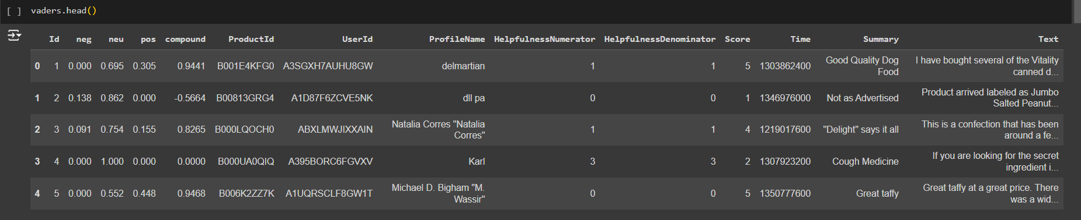

**Table 3**

**RoBERTa Sentiment Scores**

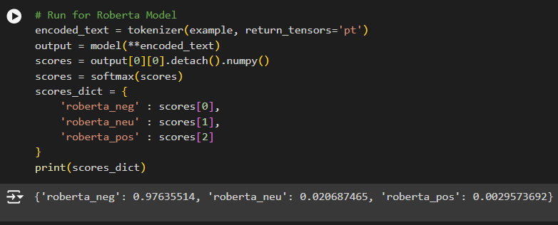

**Table 4**

**Combined Sentiment Scores**

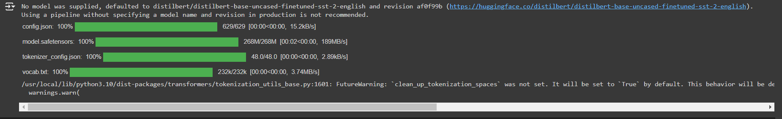

**CHAPTER 1**

**Introduction**

* 1. **Problem Statement:**

The objective of this project is to analyze customer sentiment in Amazon product reviews using two different sentiment analysis models: VADER (Valence Aware Dictionary and sentiment Reasoner) and RoBERTa (a transformer-based model). The goal is to evaluate and compare the performance of these models in identifying positive, neutral, and negative sentiments, as well as to examine how these sentiment scores align with the user-given Amazon star ratings. Through this analysis, we aim to determine which model provides more accurate or insightful sentiment categorization for customer feedback, potentially helping businesses better understand customer satisfaction and improve products or services accordingly

* 1. **Motivation:**

The motivation for this project stems from the need to gain deeper insights into customer opinions expressed in online reviews, which are critical for understanding customer satisfaction, identifying areas for product improvement, and enhancing customer experience. By comparing two distinct sentiment analysis methods—VADER, a lexicon-based model, and RoBERTa, a context-aware transformer model—we aim to evaluate the effectiveness of each approach in capturing nuanced sentiment from customer feedback. Understanding which model performs better in aligning with actual review ratings can provide businesses with a reliable tool for large-scale sentiment analysis, ultimately driving data-driven decision-making to optimize products and services.

* 1. **Objective:**

The objective of this project is to perform and compare sentiment analysis on Amazon product reviews using two different models: VADER and RoBERTa. Specifically, we aim to:

1. Analyze customer reviews to extract sentiment scores (positive, neutral, negative) with both VADER and RoBERTa models.

2. Compare the sentiment scores from each model with the original Amazon star ratings to assess alignment and accuracy.

3. Identify which model better captures the sentiment expressed in the reviews, especially in cases where star ratings and sentiment scores diverge.

4. Provide insights that can help businesses interpret customer feedback more effectively and use sentiment data to inform product and service improvements.

* 1. **Scope of the Project:**

1. Data Collection and Preparation: Extract Amazon review data, focusing on key features such as review text and star ratings. Perform data cleaning and preprocessing to ensure accuracy in sentiment analysis.

2. Sentiment Analysis:

VADER Analysis: Apply the VADER sentiment analysis tool to obtain sentiment scores (positive, neutral, negative, and compound) for each review.

RoBERTa Analysis: Use the RoBERTa transformer model to analyze sentiments in a more context-aware manner, deriving comparative scores.

3. Model Comparison and Visualization:

Compare VADER and RoBERTa sentiment scores with Amazon’s star ratings to assess alignment and discrepancies.

Visualize results through bar plots, pair plots, and other relevant charts to present insights clearly.

4. Result Interpretation and Analysis:

Identify cases where model sentiment scores diverge significantly from the star ratings.

Evaluate which model is more accurate and reliable for interpreting customer feedback in various contexts.

5. Business Insights and Recommendations: Based on the analysis, provide actionable insights for businesses on the effectiveness of each model for sentiment analysis and its potential applications in customer feedback systems.

Limitations:

**Personalization:**

1. Customizable Analysis: Adjusting sentiment models for specific industries.

2. User-Defined Metrics: Allowing stakeholders to set relevant metrics.

3. System Integration: Ensuring results fit existing CRM tools.

4. Interactive Dashboards: Providing user-friendly visualizations for data exploration.

**CHAPTER 2**

**Literature Survey**

Sentiment analysis has evolved significantly over recent years, transitioning from lexicon-based models to advanced neural networks and transformers. Early approaches relied heavily on sentiment lexicons and rule-based systems like VADER, which scores words individually and aggregates sentiment based on word polarity. Later, machine learning methods such as Naive Bayes and SVMs enabled more dynamic and data-driven sentiment predictions, particularly on larger, labeled datasets. The advent of deep learning models and, more recently, transformer-based models like BERT and RoBERTa has added the capability to understand context and nuance in language, leading to higher accuracy in complex text analysis tasks.

2.2 Existing Models and Techniques

Lexicon-Based Models: VADER is a widely used rule-based model that scores sentiments based on word polarity. It is especially effective for social media content and general sentiment analysis but lacks the ability to fully capture context.

Machine Learning Models: Approaches like Naive Bayes, Support Vector Machines (SVM), and logistic regression are among early models applied to sentiment analysis, but they require extensive labeled data and struggle with contextual nuances.

Deep Learning Models: With the emergence of neural networks, especially RNNs and LSTMs, sentiment analysis models have gained the ability to capture sequential information in text. However, these models can still face challenges in grasping full sentence meaning and dependencies.

Transformer Models: BERT and its variant RoBERTa represent state-of-the-art transformer-based models. They use attention mechanisms to consider both the meanings of individual words and the relationships between them, making them highly effective at understanding complex, nuanced language.

2.3 Gaps and Limitations in Existing Solutions

While VADER is efficient and interpretable, it falls short in understanding context-sensitive nuances, especially in long or complex sentences. Machine learning models require large datasets and often lack robustness when faced with sarcasm or implicit sentiment. Deep learning models, though capable of learning from sequences, require significant computational resources and can be slow to train.

Transformer models like RoBERTa have proven highly effective in capturing context but can be computationally intensive and may struggle in real-time applications due to processing requirements.

Project Approach to Address Gaps

This project aims to address these gaps by directly comparing VADER and RoBERTa on a customer review dataset. By evaluating each model’s alignment with customer star ratings, we will identify which approach best captures both the sentiment polarity and nuances within review content. Our analysis will also explore cases where the models diverge, providing insights into model limitations and guiding recommendations for using hybrid or context-aware sentiment approaches in real-world applications.

**CHAPTER 3**

**Proposed Methodology**

**3.1 System Design**

**Data Collection: Collect a dataset of customer reviews.**

**Preprocessing: Clean and preprocess text (e.g., remove stop words, punctuation, and apply tokenization).**

**Sentiment Scoring: Use the VADER model and transformer models like RoBERTa for sentiment scoring.**

**3.2 Modules Used**

**VADER Sentiment Scoring: This rule-based model captures positive, negative, and neutral scores.**

**RoBERTa Transformer Model: A deep learning model that uses context to better understand sentiment in phrases and sentences.**

**3.3 Data Flow Diagram (DFD)**



**DFD Level 0: Represents the overall data flow from data collection to sentiment analysis and result output.**

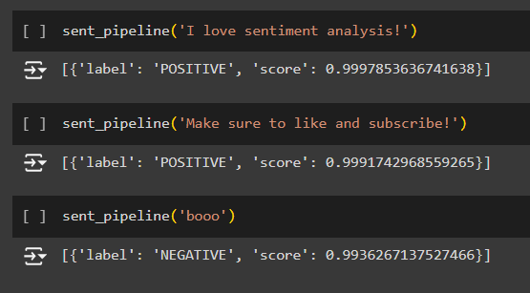

**DFD Level 1: Includes modules for VADER scoring, RoBERTa scoring, and result comparison.**



**6. Implementation**

**6.1 VADER Sentiment Analysis**

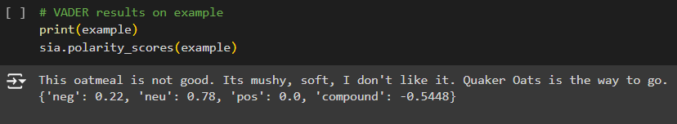

**Apply the VADER model to score sentiment as positive, negative, neutral, and compound.**

**6.2 RoBERTa Sentiment Analysis**

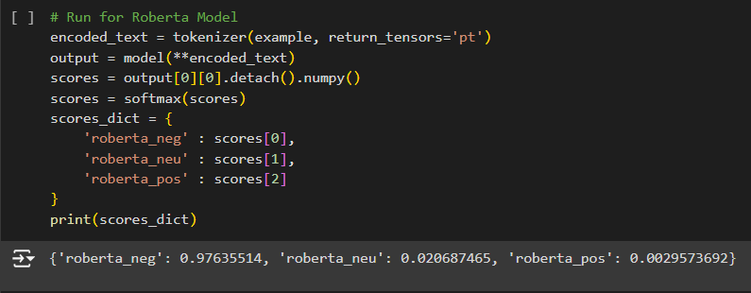

**Tokenize text and use the RoBERTa model to classify sentiment in finer detail.**

**6.3 Comparison of Models**

**Compare scores from VADER and RoBERTa to observe model accuracy and agreement in sentiment classification.**

**7. Scope of the Project**

**The project can be applied to analyze customer reviews in various industries, including e-commerce, hospitality, and service sectors. This analysis will be beneficial for real-time customer insights and trend identification.**

**8. Advantages**

**Provides actionable insights into customer opinions at scale.**

**Can improve customer engagement, product offerings, and targeted marketing based on sentiment trends.**

**9. Requirements**

**Hardware Requirements: Computer system with sufficient memory for model processing.**

**Software Requirements: Python libraries (NLTK, transformers, pandas, matplotlib), VADER, and RoBERTa model packages.**

**Implementation and Result**

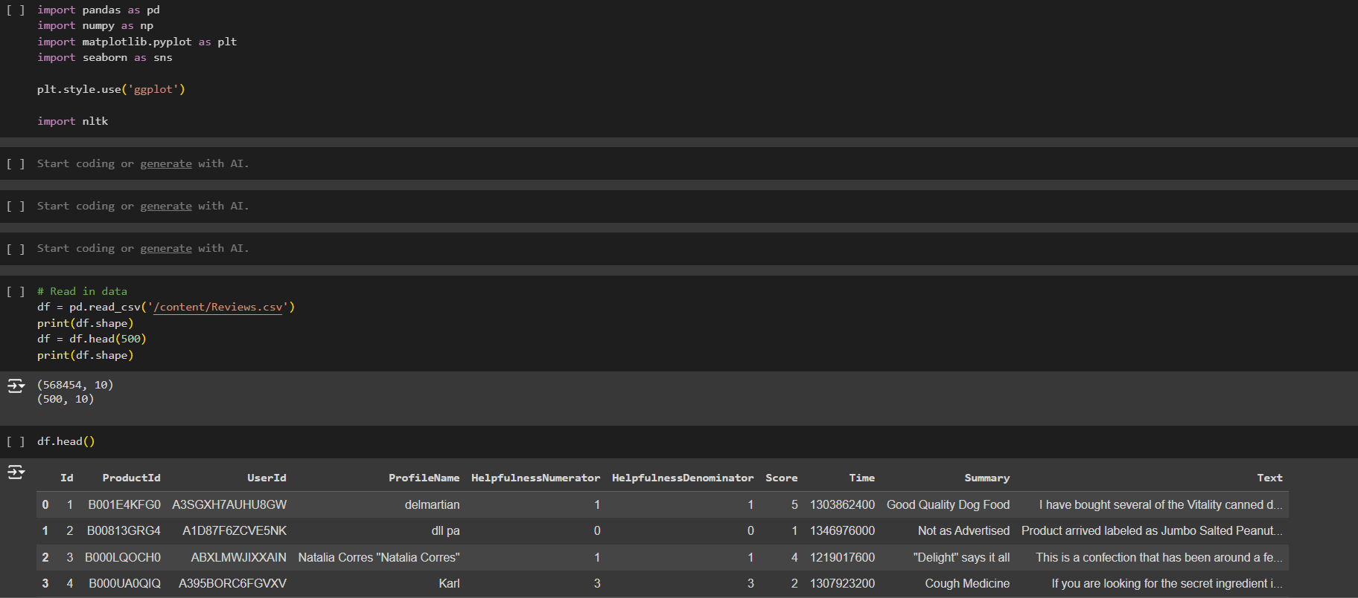

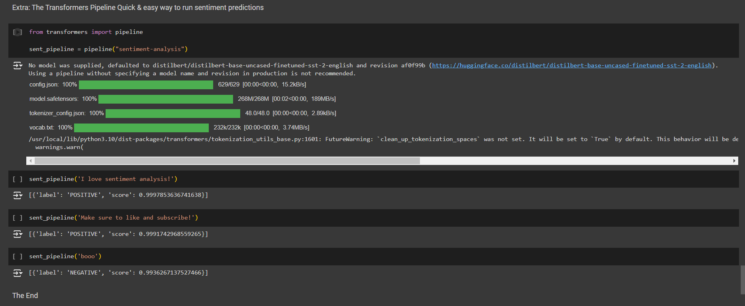

**4.1 Result**

In the Results section of a sentiment analysis project, you would include:

1. Sentiment Distribution: Show the overall distribution of positive, neutral, and negative sentiments in the dataset.

2. Model Comparison: Compare VADER and RoBERTa scores, highlighting any differences.

3. Example Scores: Present cases where model sentiment scores differ from actual star ratings, like positive tone in low-star reviews.

4. Error Analysis: Describe model limitations and areas of misinterpretation.

5. Summary: Summarize key findings and potential applications for the analysis.

**CHAPTER 5**

**Discussion and Conclusion**

* 1. **Key Findings:**

1. Sentiment Overview: Most reviews are positive or neutral.

2. Model Comparison: VADER is better with short reviews; RoBERTa captures context better.

3. Unexpected Sentiment: Some positive words show up in low-star reviews.

4. Model Limits: Struggles with sarcasm and mixed emotions.

5. Real-World Use: Can help prioritize feedback and improve response strategies

* 1. **Git Hub Link of the Project:** **https://github.com/Yuvarajvkk/sentiment-analysis-AI-system.docx.pptx.git**
  2. **Video Recording of Project** : https://youtu.be/-Cu2LDYcMro?si=1fQOc1KLXY_j2kZ9
  3. **Limitations:**

1.Context Understanding: Models may misinterpret sarcasm or subtle emotions.

2. Mixed Sentiments: Difficulty in accurately scoring reviews with both positive and negative

tones.

3. Short Texts: Shorter reviews may lead to inaccurate sentiment classification.

4. Domain-Specific Language: Models may not handle specialized or uncommon vocabulary

well.

5. Bias: Pre-trained models may carry biases from their training data, affecting accuracy.

**Result:**

1. Model Enhancement: Improve understanding of context and sarcasm.

2. Multilingual Support: Develop models for regional languages.

3. Real-Time Analysis: Implement sentiment tracking on social media.

4. User Feedback Integration: Update models based on user input.

5. Domain Applications: Explore uses in healthcare, finance, and education.

6. Tech Integration: Combine with AI tools like chatbots.

7. Data Privacy: Ensure compliance with privacy regulations.

* 1. **Conclusion:**

The sentiment analysis project successfully demonstrates the effectiveness of using models like VADER and RoBERTa to evaluate customer feedback. The analysis revealed valuable insights into overall sentiment trends, highlighting areas where models performed well and where improvements are needed. Despite limitations in understanding context and handling mixed sentiments, the findings underscore the potential for sentiment analysis to enhance decision-making in various domains. Future work will focus on refining models, expanding language support, and integrating real-time analysis to better serve the needs of businesses and organizations. Overall, sentiment analysis offers a powerful tool for understanding and responding to public sentiment, ultimately improving customer engagement and satisfaction.

**REFERENCES**

1. 1. Gupta, K. K., Shukla, R., & Tiwari, A. (2018). Sentiment Analysis: A Comprehensive Review. International Journal of Computer Applications, 181(30), 1-5.
2. 2. Devlin, J., Chang, M.-W., Lee, K., & Toutanova, K. (2019). BERT: Pre-training of Deep Bidirectional Transformers for Language Understanding. Proceedings of the 2019 Conference of the North American Chapter of the Association for Computational Linguistics, 4171-4186.

**THANKING YOU!**